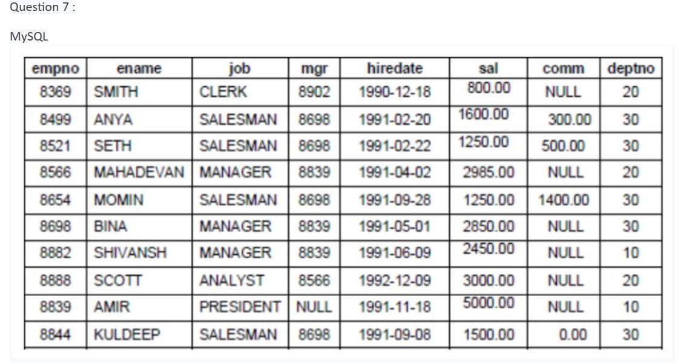

1.) Consider the Employee table and write SQL command to get the following.

- Write a query to display EName and Sal of employees whose salary are greater than orequal to 2200?
  - Query: select ename,sal from employees where sal>2200 or sal=2200;

B. Write a query to display details of employees who are not getting commission?
  - Query: select * from employees where comm is null;

C. Write a query to display employee name and salary of those employees who don't have their salary in the range of 2500 to 4000?
  - Query: select ename,sal from employees where sal not between 2500 and 4000;

D. Write a query to display the name, job title and salary of employees who don't have amanager?
  - Query: select ename,job,sal from employees where mgr is null;

E. Write a query to display the name of an employee whose name contains "A" as third
alphabet?
  - Query: select ename from employees where ename like “__A%”;

F. Write a query to display the name of an employee whose name contains "T" as the last
alphabet?
  - Query: select ename from employees where ename like “%T”;

